Henry Fundenberger

Math 434 – Lab 1

1. Some basic commands using arrays.

x = -2:.1:2;

f = inline('x.^3 - 2\*x','x');

y = f(x);

plot(x,y)

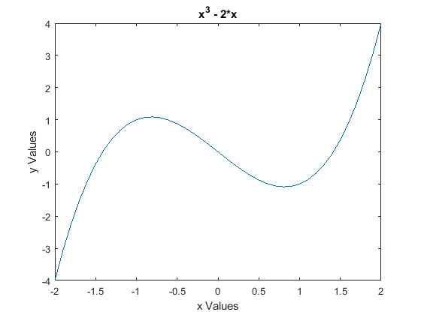

1.) Some basic commands using arrays.

b.)

x = -2:.05:2; y = x;

Z = sin(x'\*y); mesh(Z)

xlabel('x')

ylabel('y')

zlabel('z')

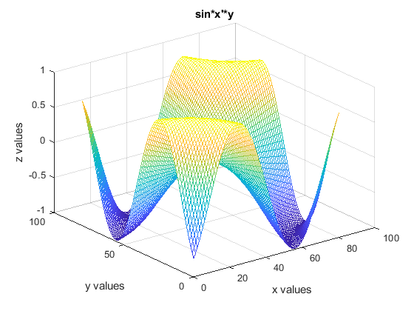

1.) Some basic commands using arrays.

c.)

A = [1 2 3; 4 5 6; 7 8 10], C = [1 2; 3 4; 5 6]

A =

1 2 3

4 5 6

7 8 10

C =

1 2

3 4

5 6

A\*C

ans =

22 28

49 64

81 106

b = [1 2 3]', A\b

b =

1

2

3

ans =

-0.3333

0.6667

0.0000

1.) Some basic commands using arrays.

d.)

U = [1 5 6 10], V = [2 3 4 6]

U =

1 5 6 10

V =

2 3 4 6

U.\*V

ans =

2 15 24 60

dot(U,V)

ans =

101

V.^3

ans =

8 27 64 216

exp(V)

ans =

7.3891 20.0855 54.5982 403.4288

2.) Making vectors

a.)

b = [1 2 3 4]

b =

1 2 3 4

b.)

b=b'

b =

1

2

3

4

2.) Making vectors

c.)

xx = 0:.1:2

xx =

Columns 1 through 5

0 0.1000 0.2000 0.3000 0.4000

Columns 6 through 10

0.5000 0.6000 0.7000 0.8000 0.9000

Columns 11 through 15

1.0000 1.1000 1.2000 1.3000 1.4000

Columns 16 through 20

1.5000 1.6000 1.7000 1.8000 1.9000

Column 21

2.0000

d.)

yy = linspace(0,3,13)

yy =

Columns 1 through 5

0 0.2500 0.5000 0.7500 1.0000

Columns 6 through 10

1.2500 1.5000 1.7500 2.0000 2.2500

Columns 11 through 13

2.5000 2.7500 3.0000

3.) Making matrices

a.)

A = [1 2 3; 4 5 6]

A =

1 2 3

4 5 6

b.)

C = eye(3)

C =

1 0 0

0 1 0

0 0 1

c.)

D = ones(4)

D =

1 1 1 1

1 1 1 1

1 1 1 1

1 1 1 1

3.) Making matrices

d.)

E = zeros(5,3)

E =

0 0 0

0 0 0

0 0 0

0 0 0

0 0 0

e.)

F = rand(2,3)

F =

0.8147 0.1270 0.6324

0.9058 0.9134 0.0975

f.)

G = randn(5)

G =

-0.4336 3.0349 -0.1241 -1.2075 0.7269

0.3426 0.7254 1.4897 0.7172 -0.3034

3.5784 -0.0631 1.4090 1.6302 0.2939

2.7694 0.7147 1.4172 0.4889 -0.7873

-1.3499 -0.2050 0.6715 1.0347 0.8884

3.) Making matrices

h.)

H = hilb(5)

H =

1.0000 0.5000 0.3333 0.2500 0.2000

0.5000 0.3333 0.2500 0.2000 0.1667

0.3333 0.2500 0.2000 0.1667 0.1429

0.2500 0.2000 0.1667 0.1429 0.1250

0.2000 0.1667 0.1429 0.1250 0.1111

i.)

P = pascal(4)

P =

1 1 1 1

1 2 3 4

1 3 6 10

1 4 10 20

4.) Basic Operations

a.)

B = A'

B =

1 4

2 5

3 6

b.)

A\*C

ans =

1 2 3

4 5 6

c.)

C\*A

Error using \*

Incorrect dimensions for matrix multiplication. Check that

the number of columns in the first matrix matches the

number of rows in the second matrix. To operate on each

element of the matrix individually, use TIMES (.\*) for

elementwise multiplication.

4.) Basic Operations

d.)

x = P \ b

x =

0

1

0

0

e.)

P\*x

ans =

1

2

3

4

5.)

a.)

x = [2 4]

x =

2 4

>> y = [6 8]

y =

6 8

b.)

i.)

x \* y'

ans =

44

ii.)

x' \* y

ans =

12 16

24 32

iii.)

x .\* y

ans =

12 32

6.)

A = 20;

f0 = 1;

t=0:1/12:10;

y = A\*cos(2\*pi\*f0\*t);

plot(t,y,'-r')

xlabel('tn')

ylabel("y Values of the function")

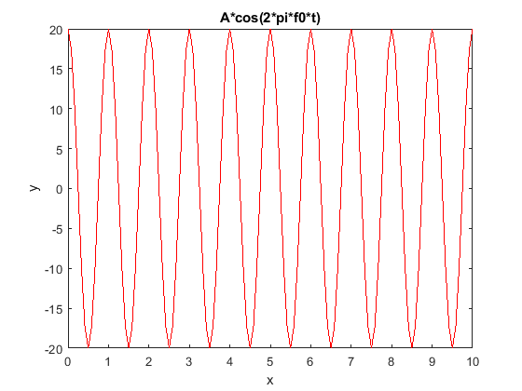

7.)

z = y.^2;

subplot(2,1,1)

plot(t,y,'-r')

xlabel('t')

ylabel("Y Values of the Function")

subplot(2,1,2)

plot(t,z,'-b')

xlabel('t')

ylabel("Y Values of the Function")

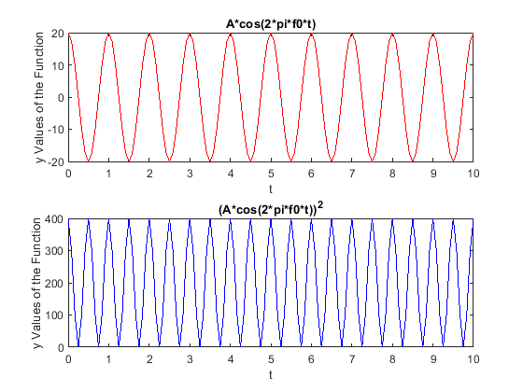

8.)

a.)

i^i

ans = 0.2079

This is the correct answer because if we look at Euler's formula

e^(ix) = cosx \* I\*sinx. We can solve that I is equal to e^(I\*pi/2) and if we raise I^I we get e^(I\*pi/2)^I, since I \* I = -1 we can calculate e^-pi/2 which is equal to 0.2079.

b.)

P = 4+3\*x^3-(1-i)\*x;

x = [i^i];

y = polyval(P,x);

y = 3.8191 + 0.2079i